Bash Scripting-01
About bash scripting:- bash is very important for automation task it help save us time
- :- it can handle our task such as free -m, ps -ef, df, du -sk (login to server and verify every day.) it make our work fast simple
To automate all the above commands every day, we follow Bash Scripting.
Process below:-
Use micro or vi to write the commands for your script (the automation). After writing ur script make sure give it permission ( chmod 777 name)

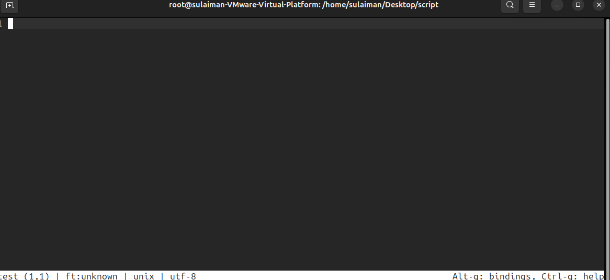
It our dash board where used write script excute it automation task

#!/bin/bash = it called Shebang It's a mandatory instruction that says, "Hey, computer! Use the Bash shell to read and run the rest of the commands in this file."
After writing script just save ur script press ctrl+s and quite ctil+q

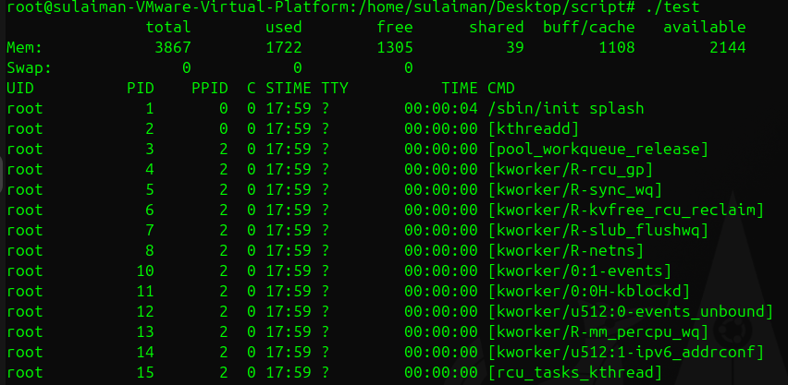
You can notice that our script is working

1 Which shell are you using right now
Command:-echo $0
Meaning: You are telling the computer: "Just tell me the name of the program I am currently using to type these commands
:- It usually prints back the name of the shell you are in, like bash.

Find all available shells on the system?
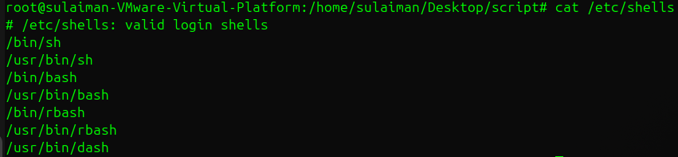
Command: cat /etc/shells
Meaning: The /etc/shells file is a master list of all the different command programs (shells) installed on the computer. The cat command is used just to read and display the contents of that file quickly.
:- You see a list of every available shell, such as /bin/bash, /bin/sh, /bin/zsh, etc.
Find out which shell each user uses?
Command: cat /etc/passwd
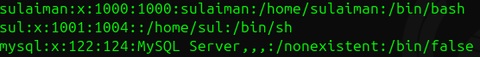
Meaning: The /etc/passwd file is a record that holds information for every user account on the system. You use cat to read this file. For each user listed, the very last piece of information on their line shows their default shell (the shell that starts when they log in).
Example: You see a list of users and the shell program assigned to them.

How to Change Your Shell Temporarily
Just type the name of the shell you want to use.
When you type the name of another shell (sh, csh, tcsh, etc.) and press Enter, your current shell immediately starts up the new shell on top of itself.
Here we are using :- sh shell
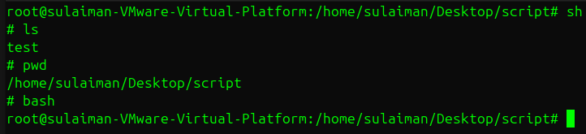
Here we are using :- cs shell
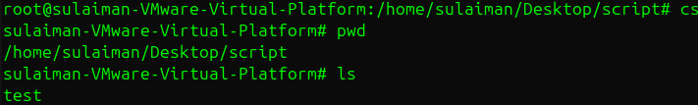
If went use your shell simple type ur shell name like bash and it switch ur shell

